EXPERIMENT 1A
SETTING UP PYTHON ENVIRONMENT AND LIBRARIES – JUPYTER NOTEBOOK

Aim :
To install Python, configure Jupyter Notebook, understand the notebook environment, execute Python programs, create Markdown cells, and use basic Jupyter Notebook features for Data Analytics applications.

Algorithm :
- Start the program.
- Import the required libraries (if needed).
- Declare and initialize the required variables or data.
- Perform the required operations or processing.
- Display the output/results.
- Stop the program.

Code :

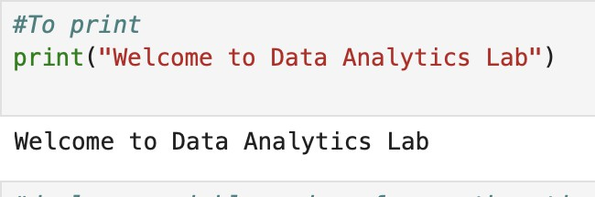

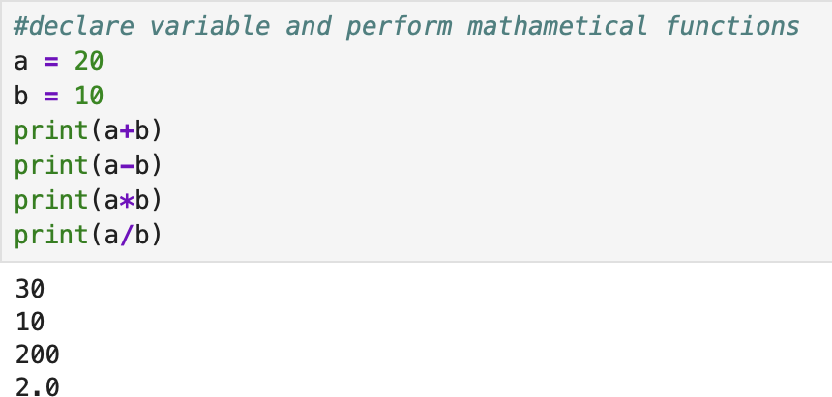

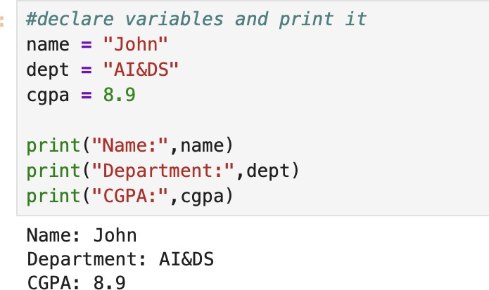

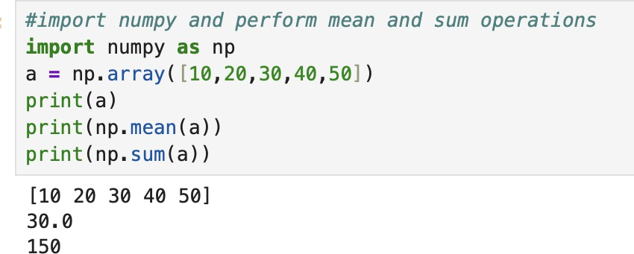

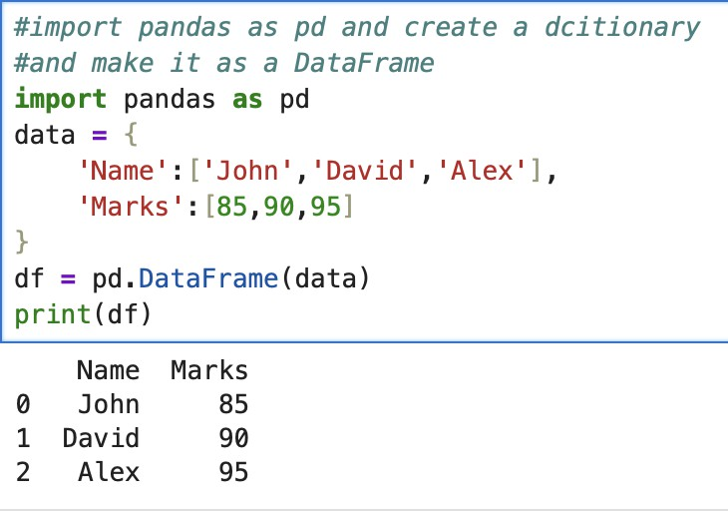

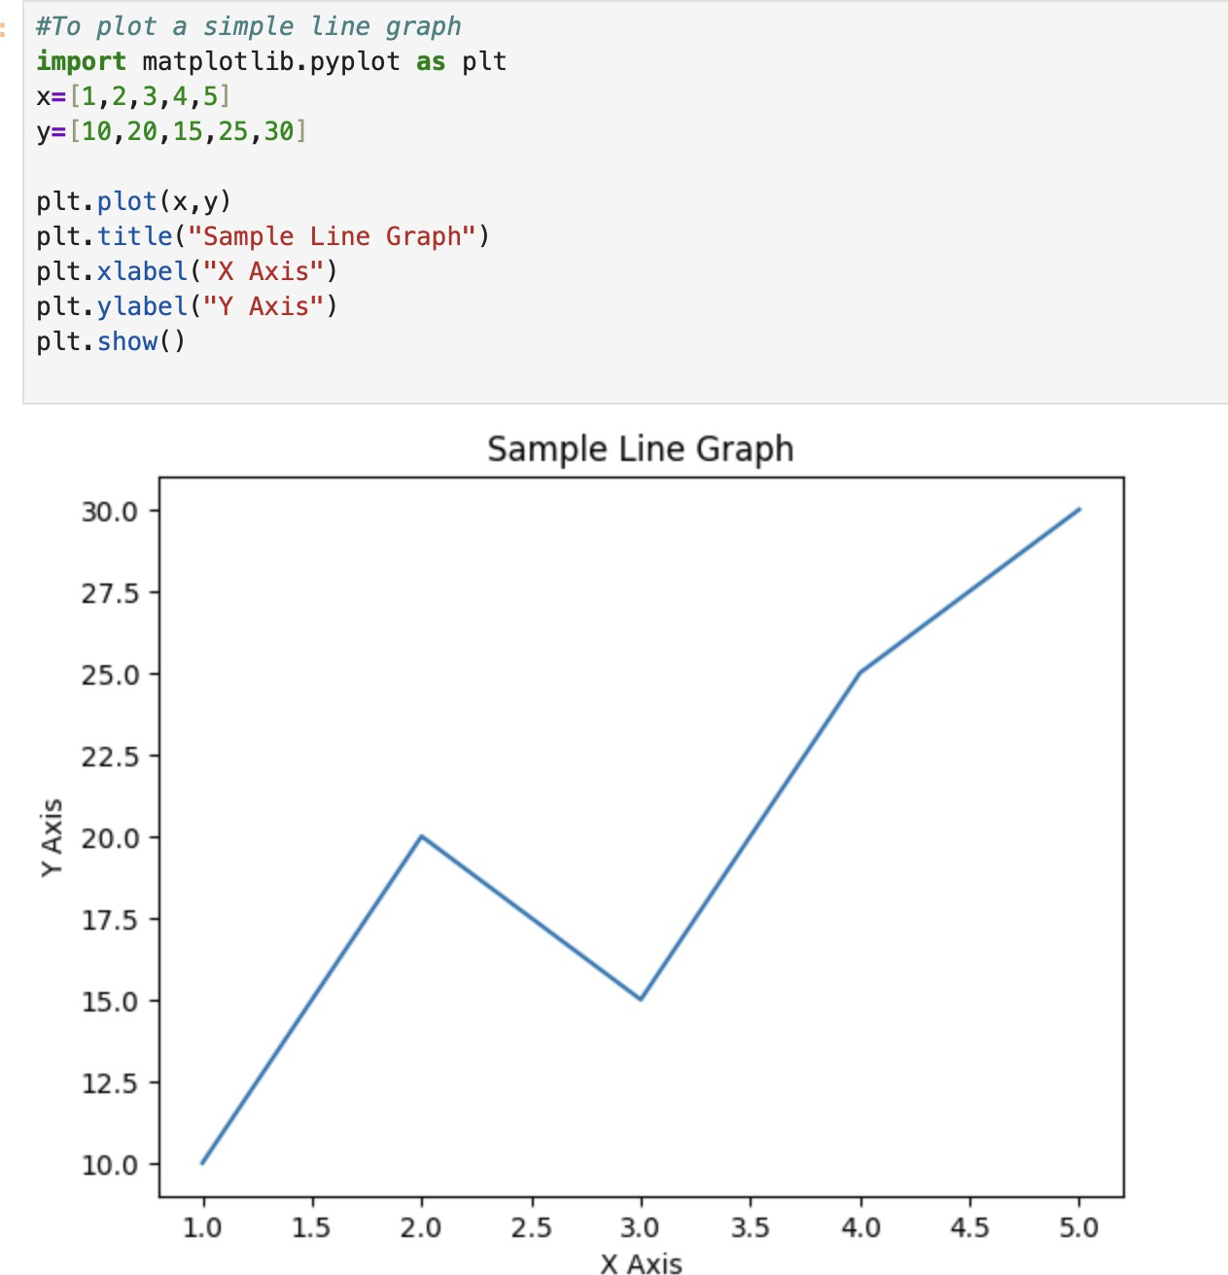

Result :
The program to perform basic mathematical operations is completed successfully

